**Class:** Final Year (Computer Science and Engineering)

**Year:** 2021-22 **Semester:** 1 **Course:** High Performance Computing Lab

**PRN:** 2018BTECS00049

**Practical No. 7**

**Problem Statement 1: Setup the environment requirements, for execution of CUDA C programs.**

I have used Google Colab for CUDA pratical as there is no GPU in my Laptop. So there is no setup.

**Ans:**

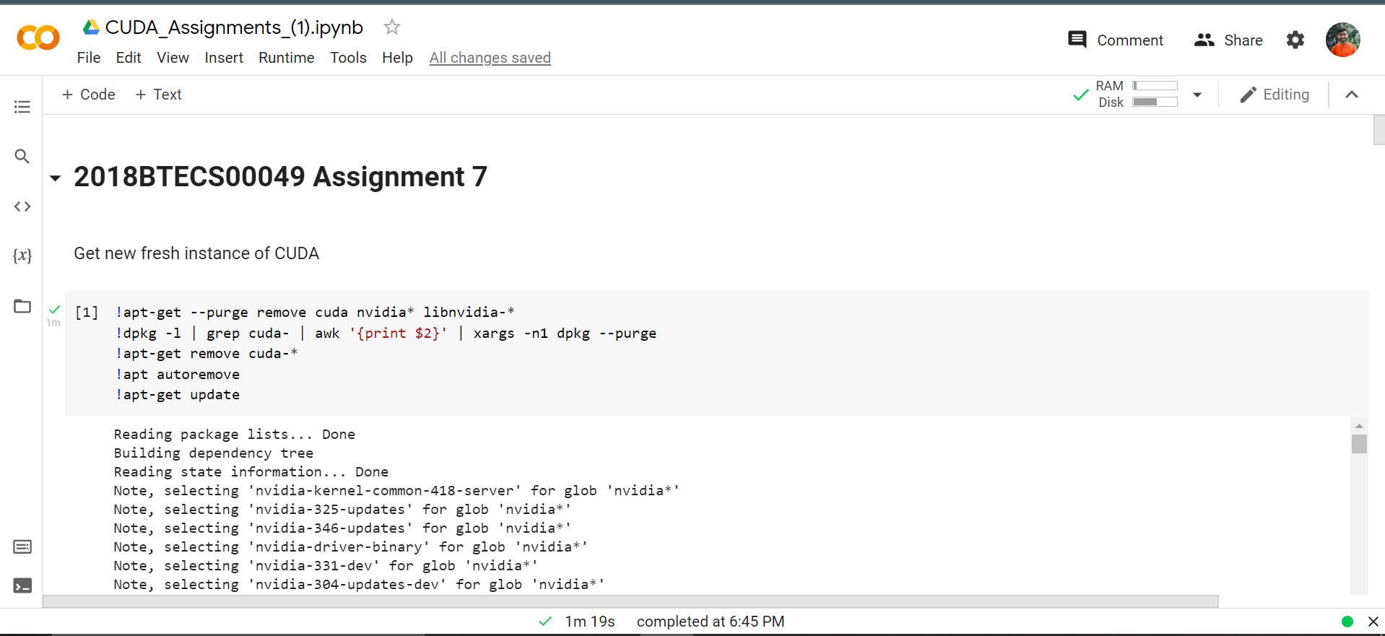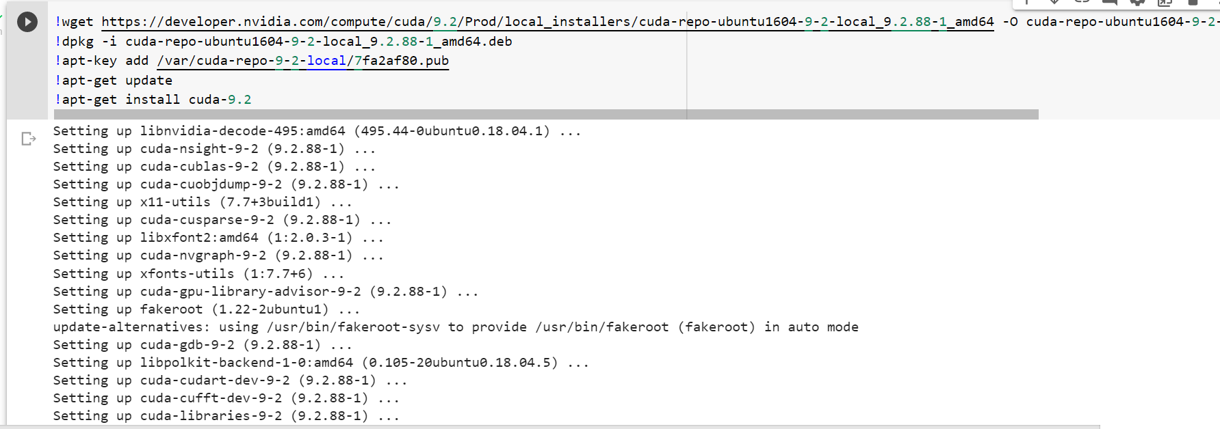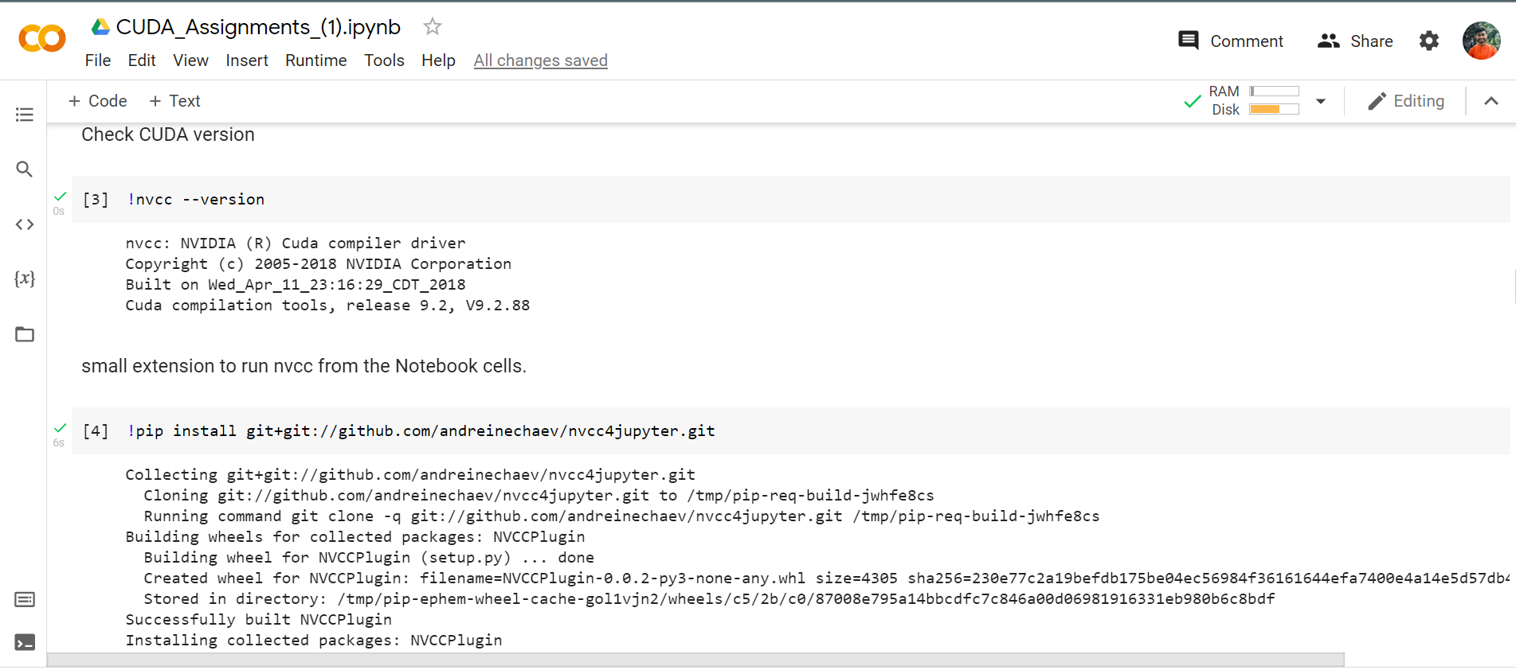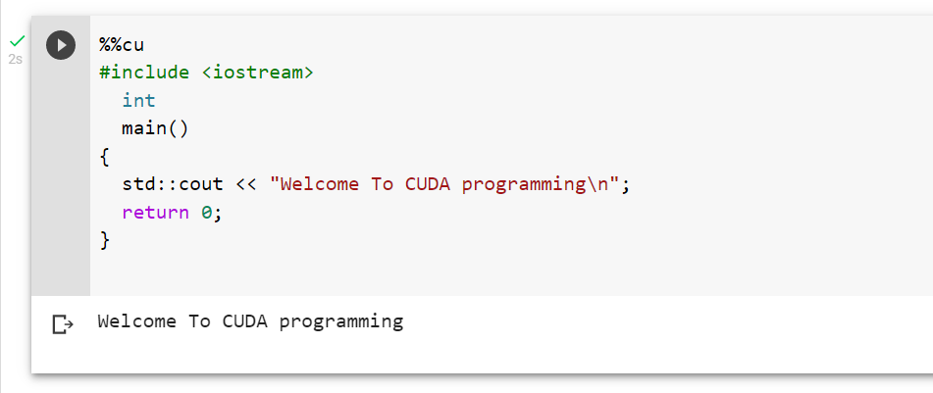

**Problem Statement 2: Execute the attached Program 1, and understand the output**

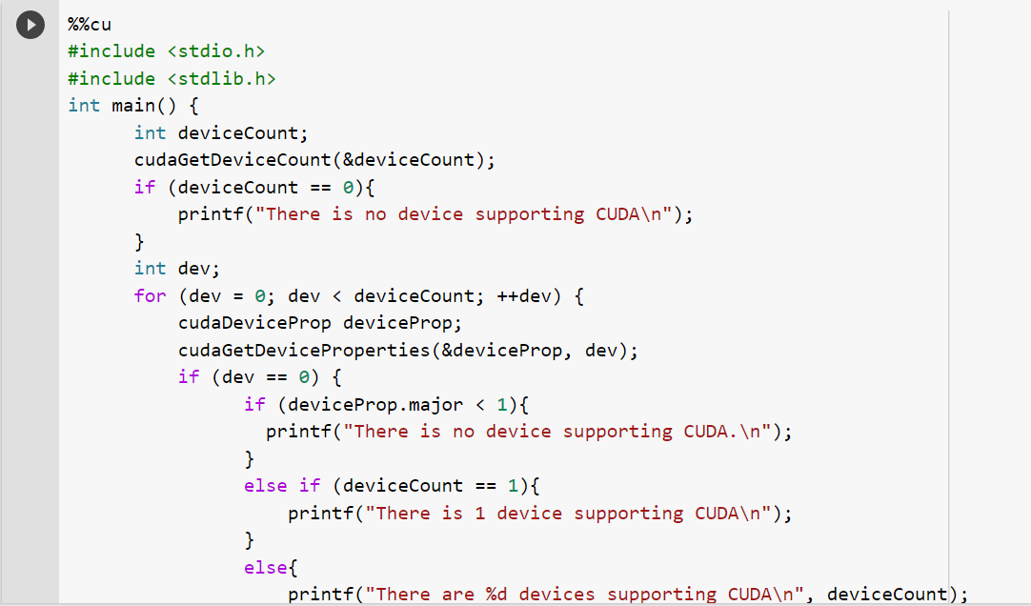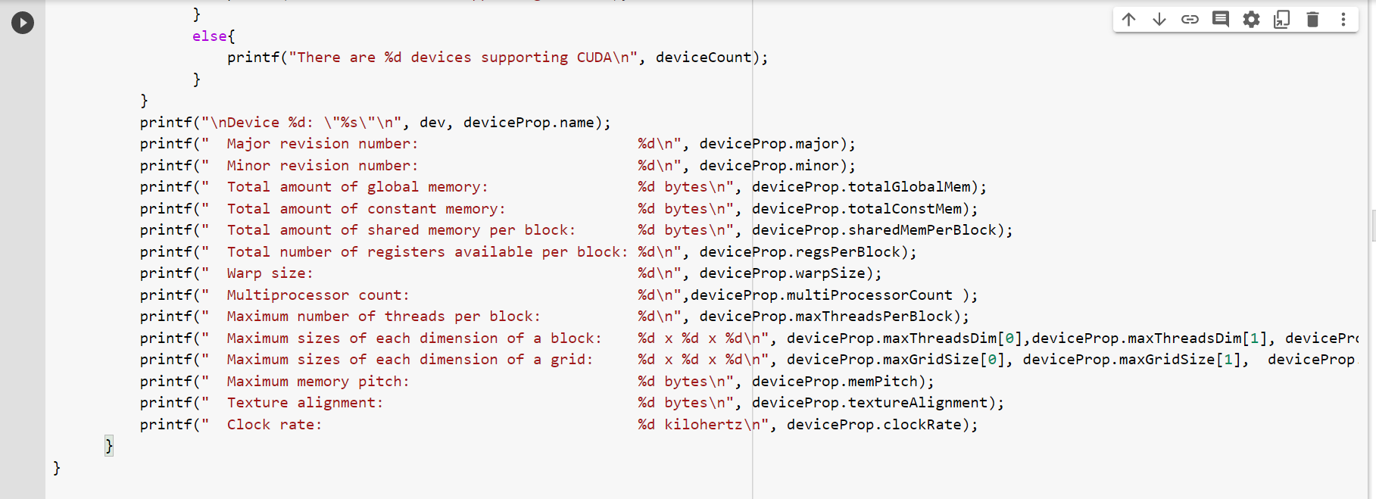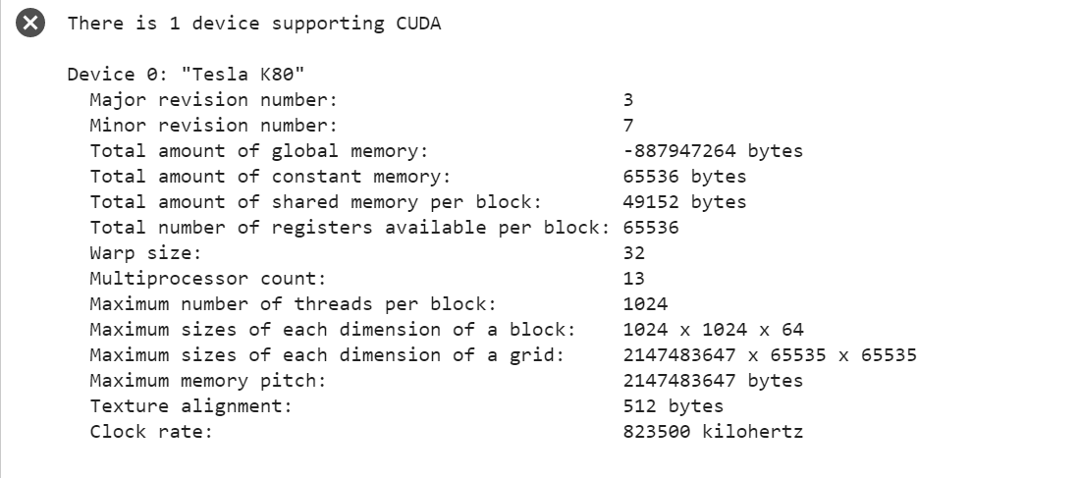

**Problem Statement 3: Write a CUDA C program to perform the addition of two vectors of arbitrary size (Dynamic Array).**

